**Diseasome Biological Network**

* Project Report by Aniket raj
* RA2211003011188
* B2-SECTION
* CTECH DEPARTMENT

**Background:**

A network of disorders and disease genes linked by known disorder–gene associations, indicating the common genetic origin of many diseases. Genes associated with similar disorders show both higher likelihood of physical interactions between their products and higher expression profiling similarity for their transcripts, supporting the existence of distinct disease-specific functional modules.

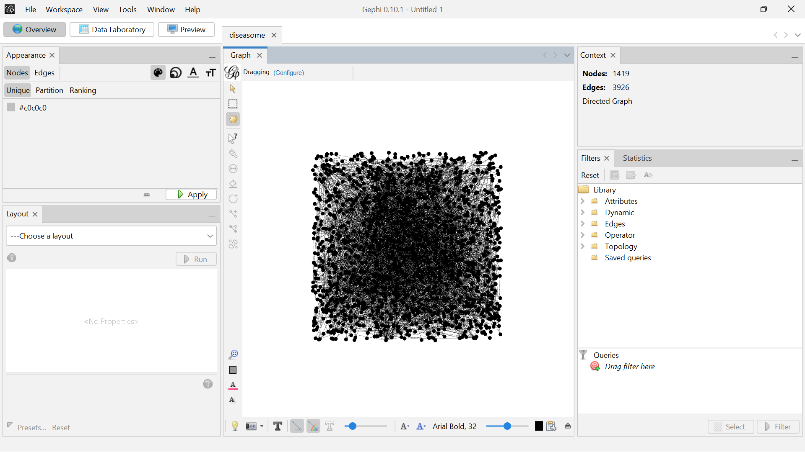

**Initial Visualization:**



**Layout Alteration:**

**Force Atlas 2** is a popular layout algorithm used in Gephi, a software for network visualization and analysis. It’s especially suited for visualizing large, complex networks. The algorithm positions nodes based on a force-directed approach, simulating physical forces like attraction and repulsion to reveal the network’s structure in an intuitive way.

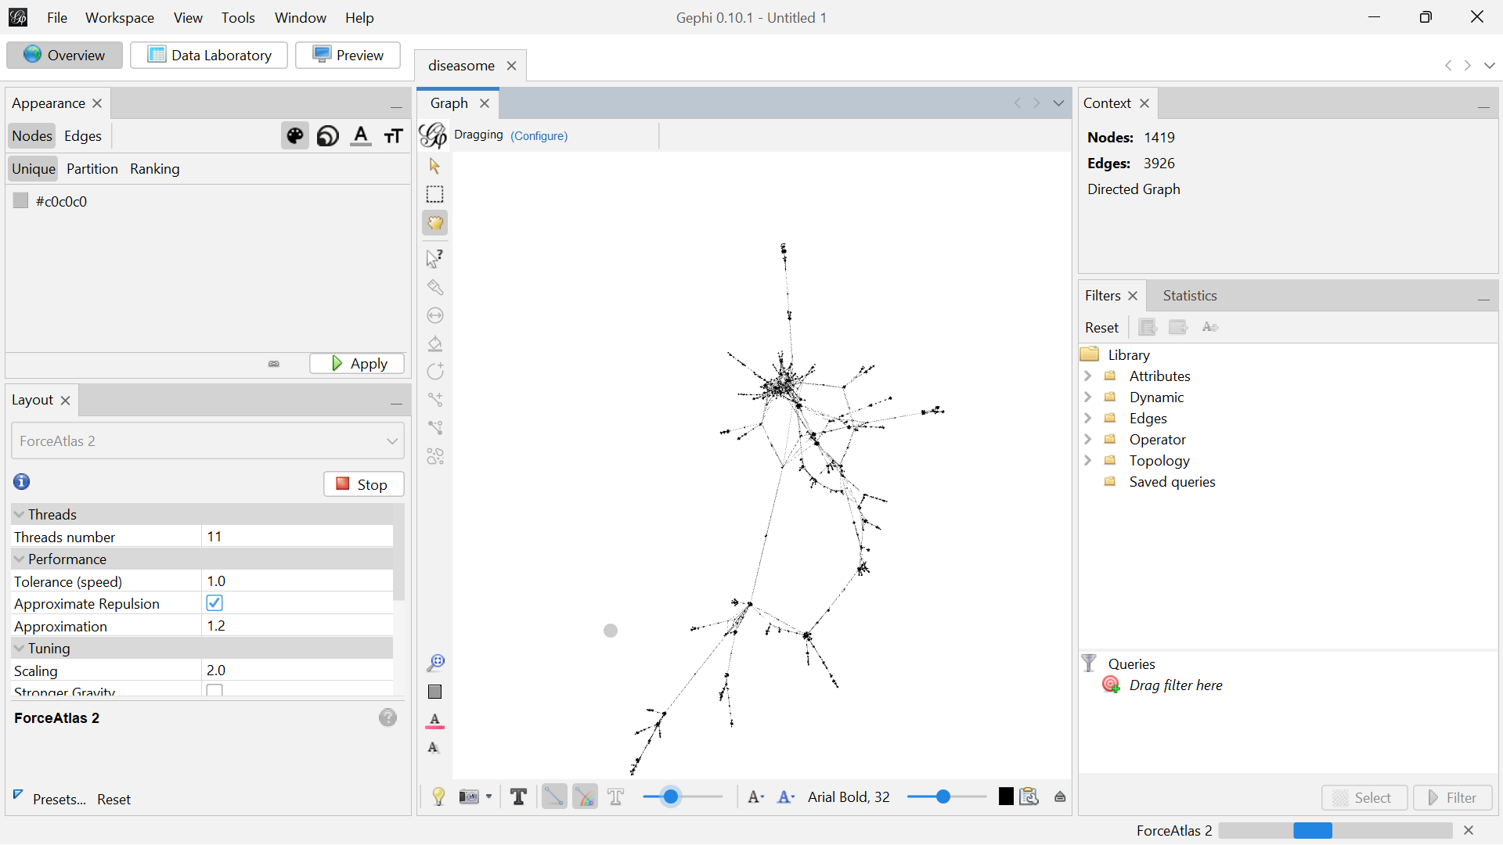



**Basic Statistics:**

**Data Laboratory:**

In Gephi, the Data Laboratory is a workspace that allows you to interact with your data in a tabular format, similar to how you would work with spreadsheets. It provides a user-friendly interface to view, edit, and manipulate your graph’s node and edge data directly.

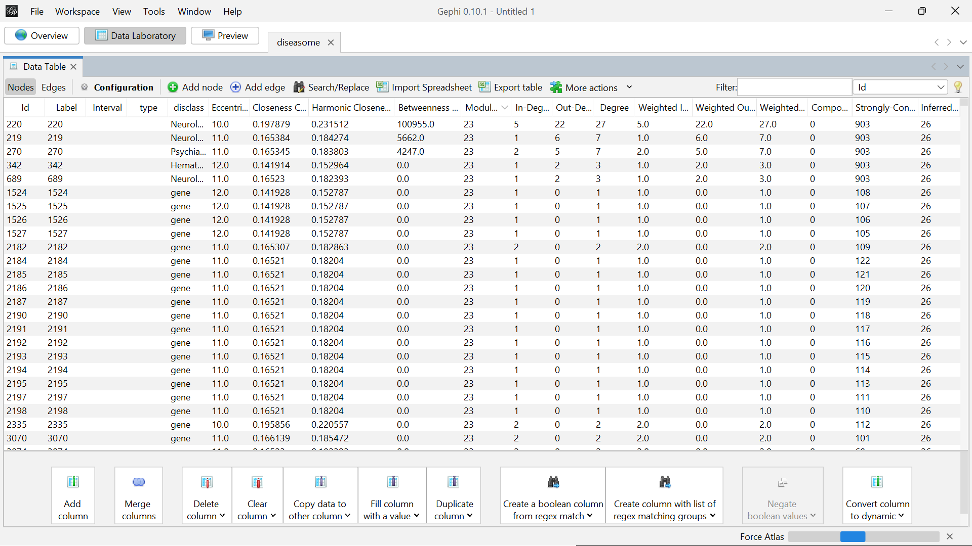

**Average Degree:**

Average Degree is a network metric that represents the average number of connections (edges) each node has within the graph. It is a fundamental measure that gives an idea of how connected the nodes are on average.

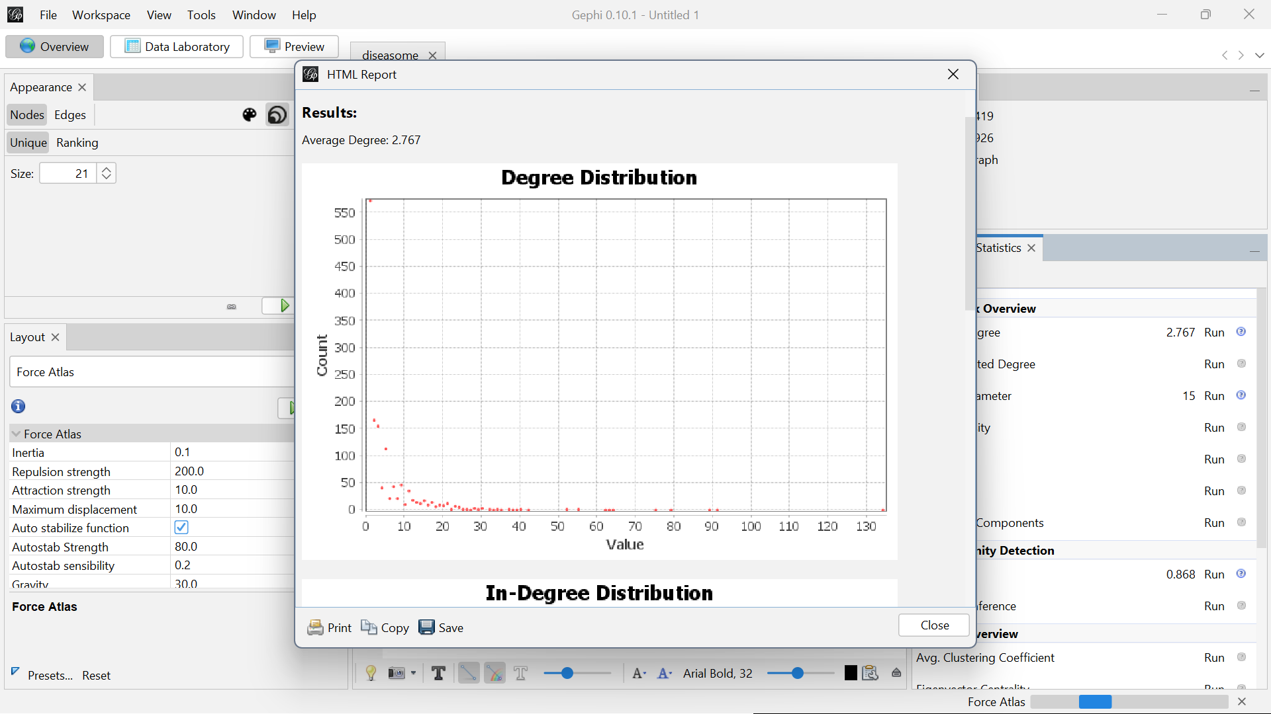

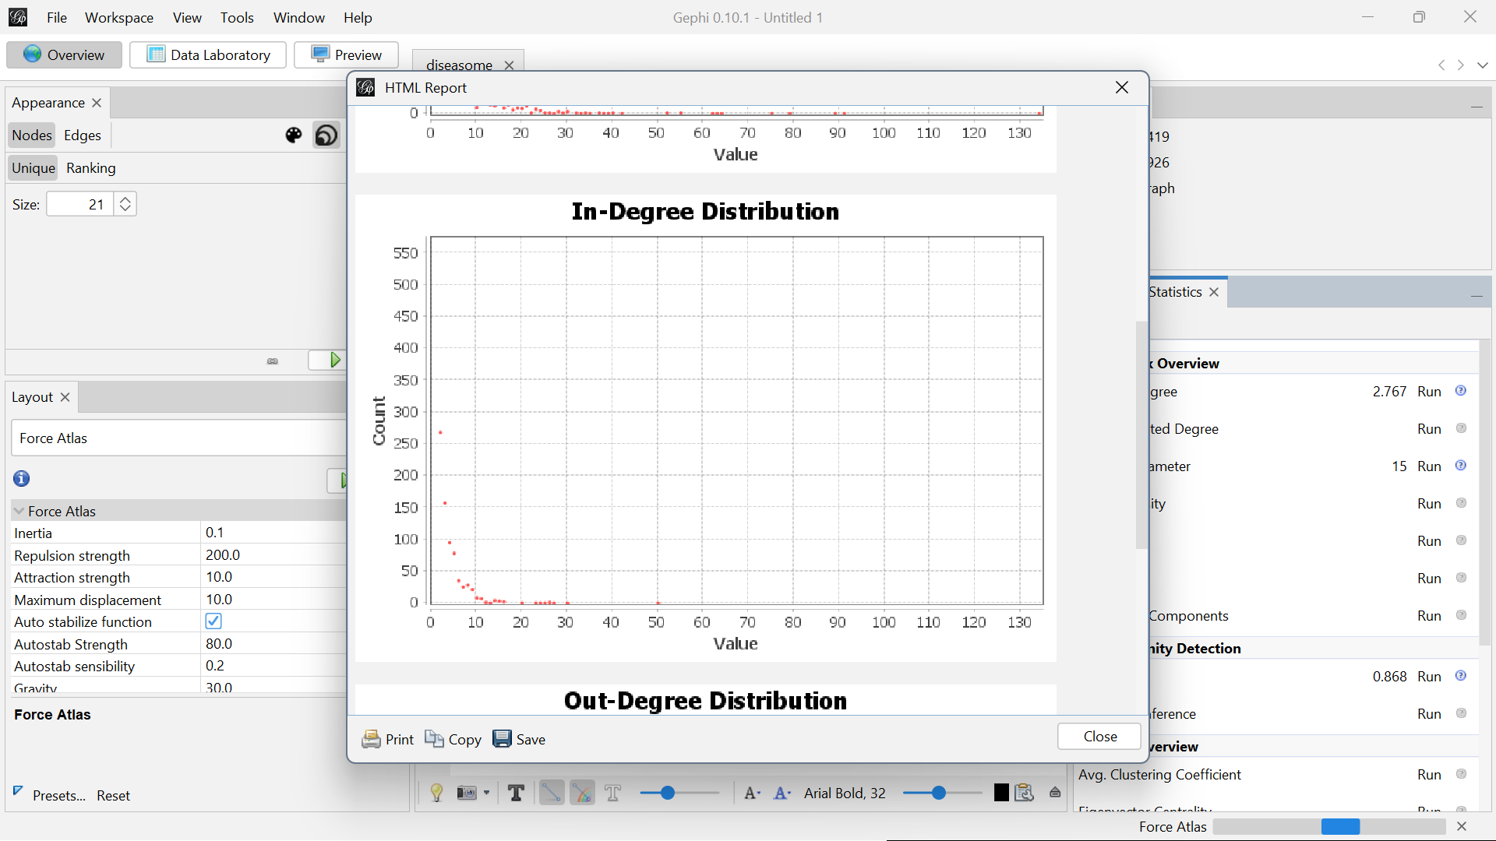

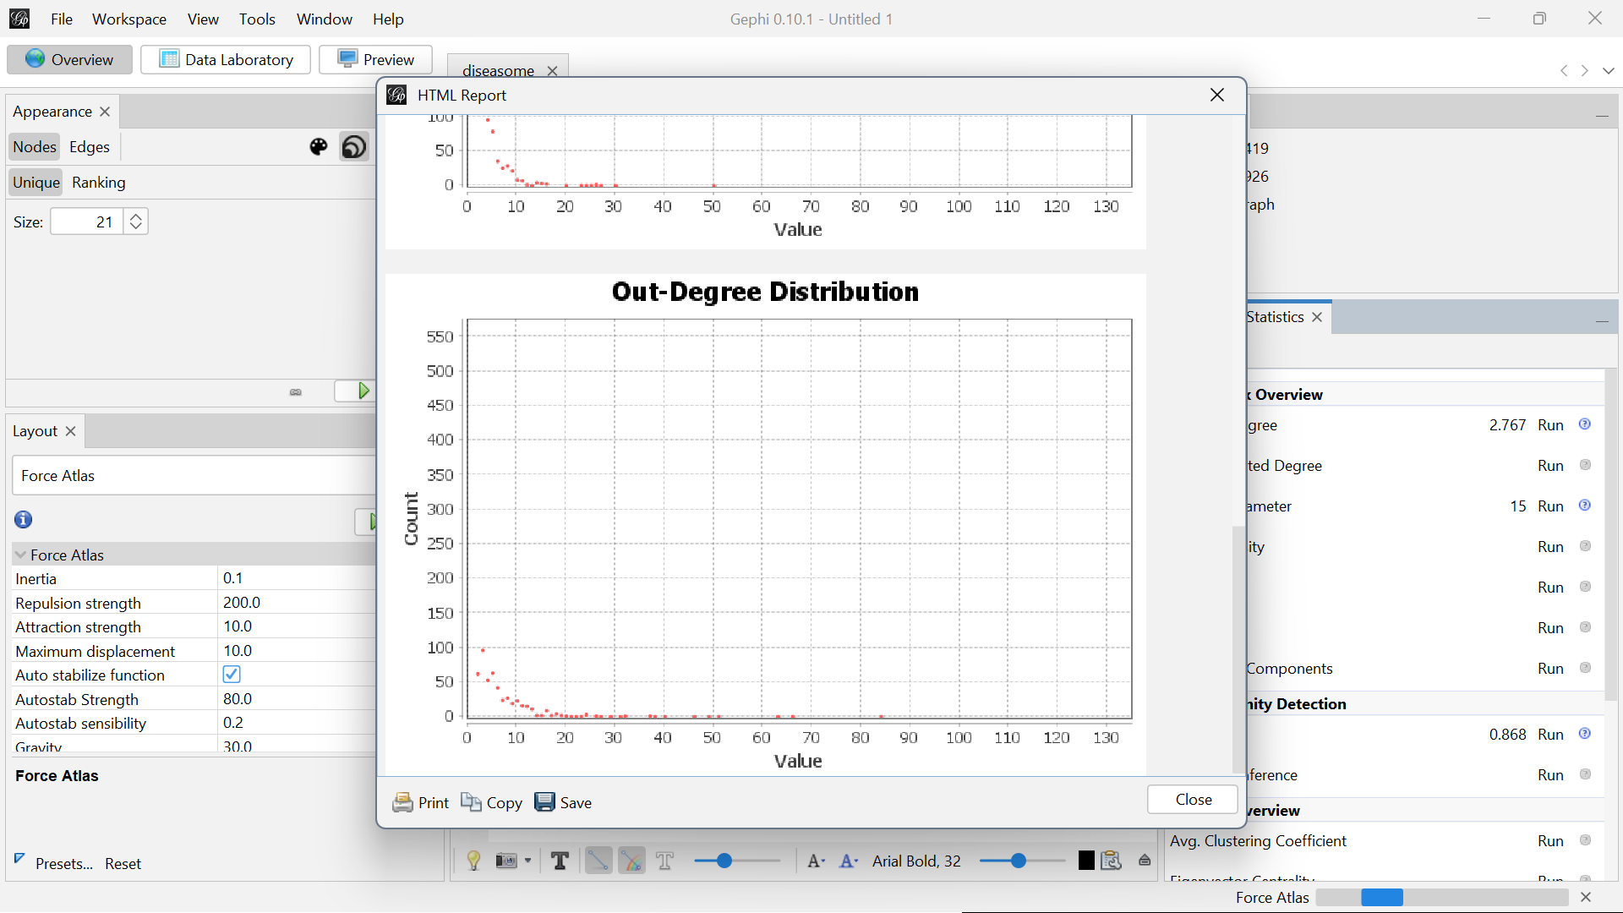

**Network Diameter:**

Network Diameter is a measure of the longest shortest path between any two nodes in a graph. It gives an indication of the "size" of the network in terms of how far apart nodes can be from one another.

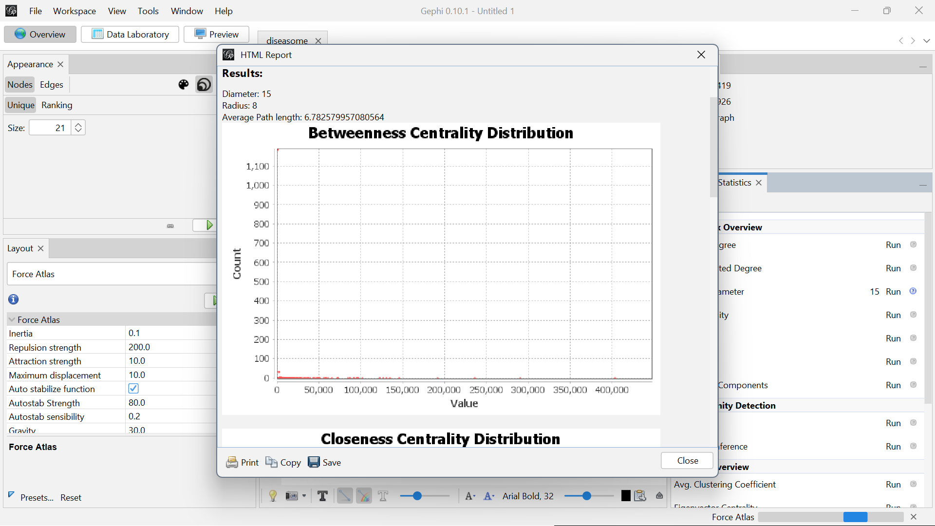

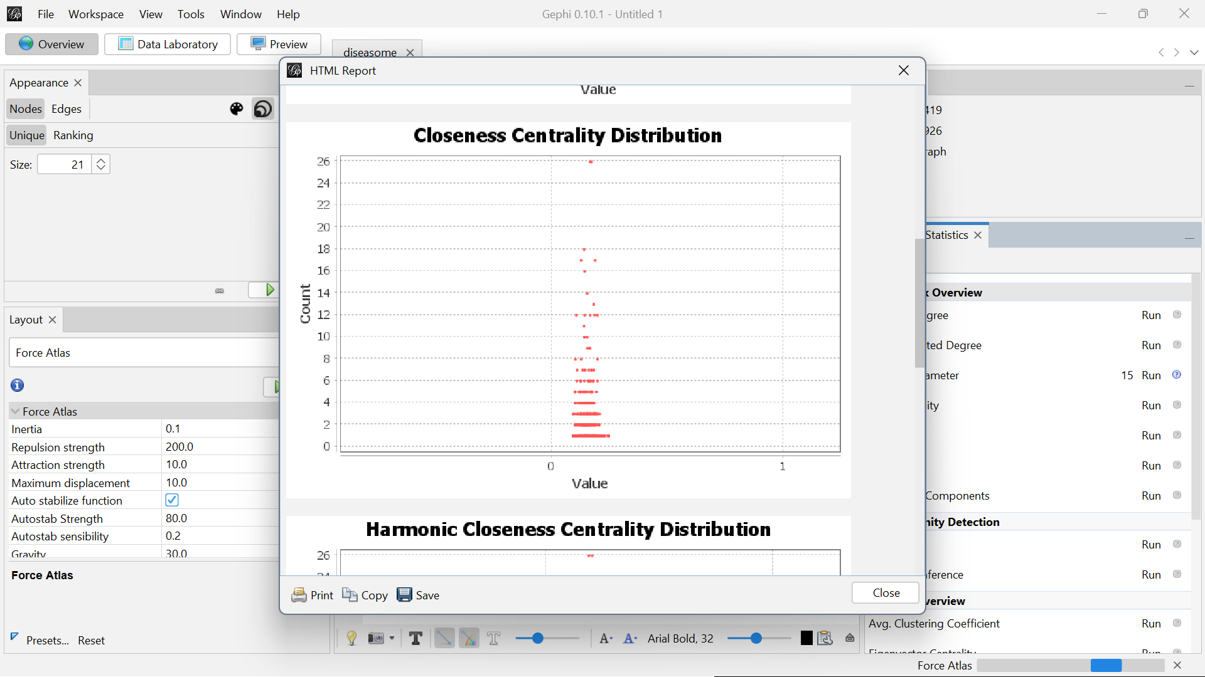

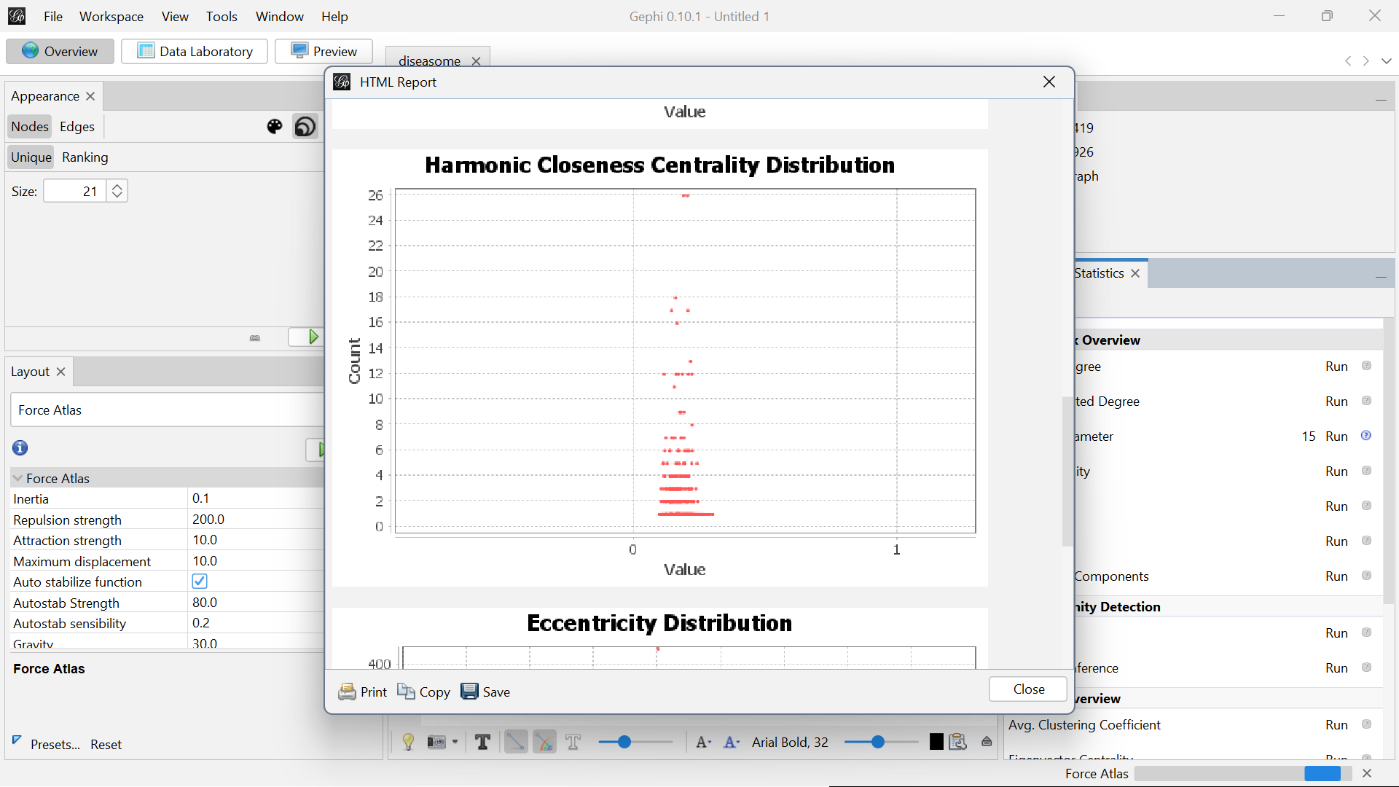

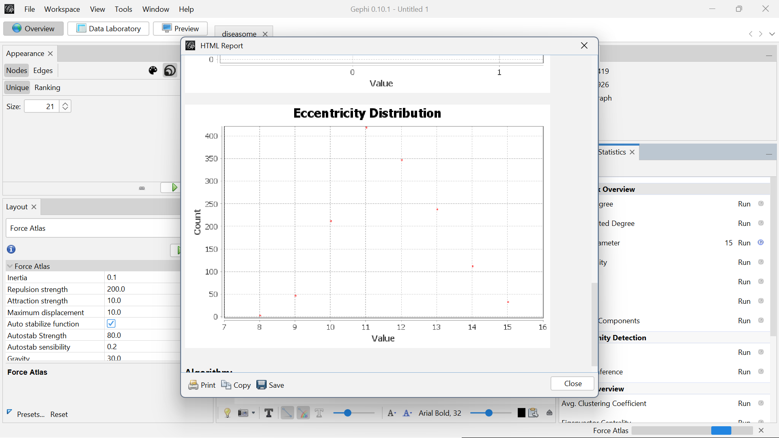

**Modularity Report:**

Modularity Report provides information about the community structure within a network. Modularity is a measure that evaluates the strength of division of a network into modules or communities. These communities are groups of nodes that are more densely connected internally than with the rest of the network.

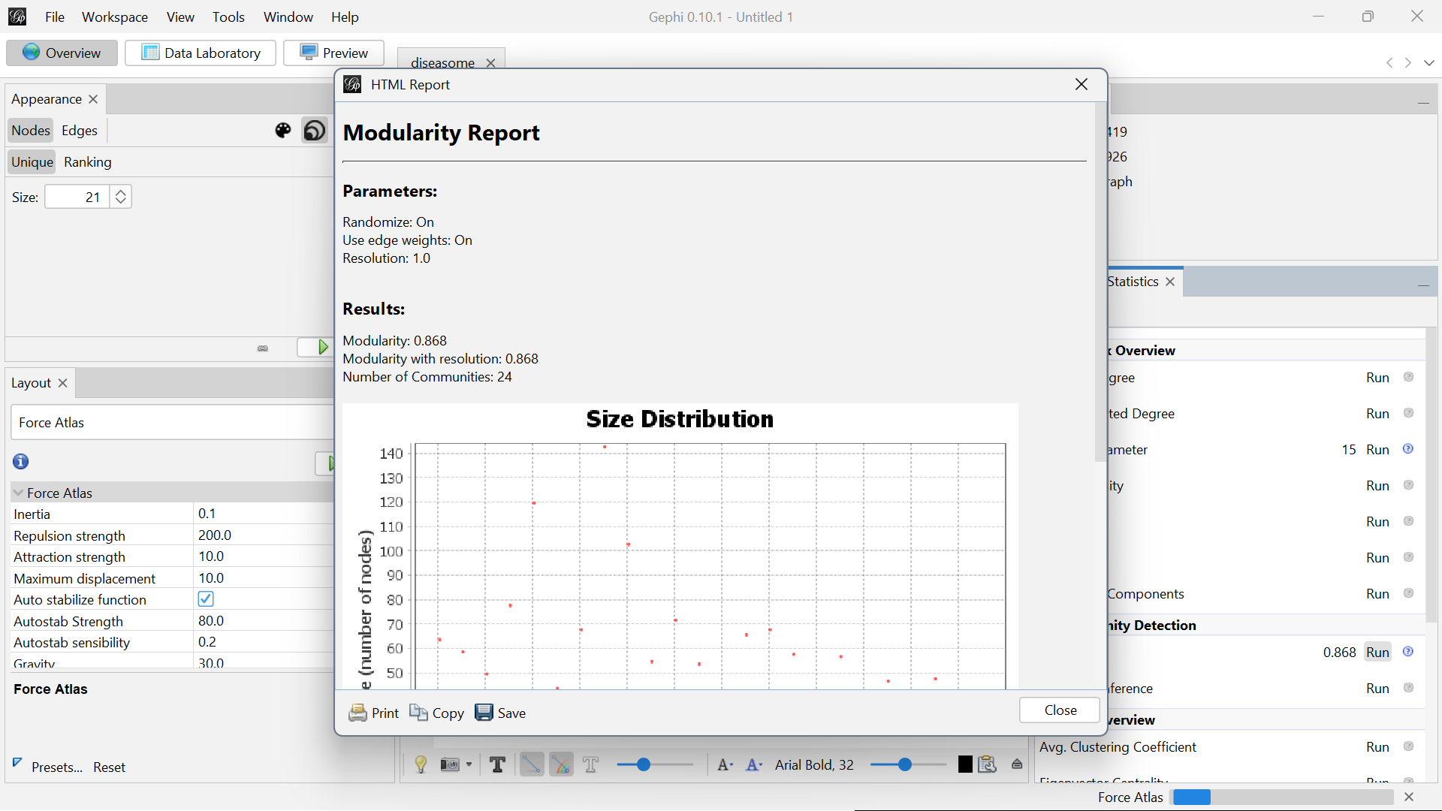

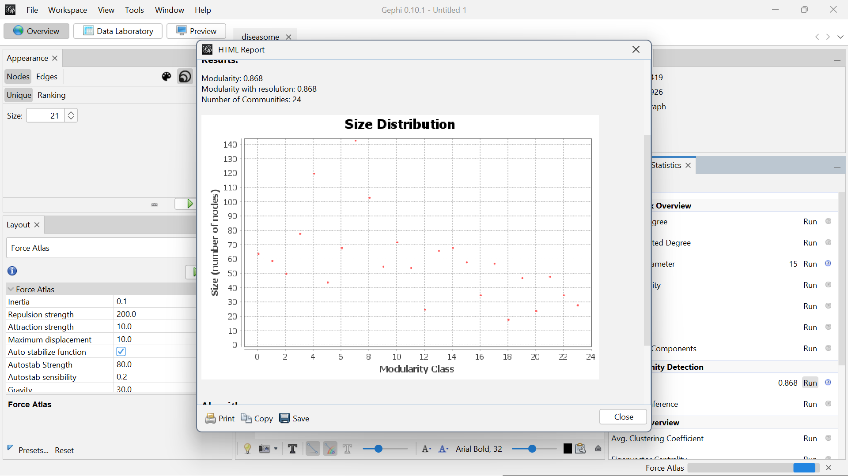

**Appearance Settings:**

**Based on Nodes:**

Appearance settings allow you to customize how nodes (and edges) are visually represented in your graph. These settings help you highlight key patterns and insights by adjusting node size, color, labels, and more based on different attributes.

Appearance Settings Based on Nodes:

1. Node Color:

You can color nodes based on:

* Partition: Assigns colors based on categorical data (e.g., communities, types, categories). Each distinct value is assigned a different color.
* Ranking: Colors nodes based on a numerical or ordinal attribute (e.g., degree, betweenness centrality). You can set a gradient or spectrum to represent different ranges of values.
* Attribute Values: Directly map colors to specific attribute values in your dataset.

1. Node Size:

You can scale the size of nodes based on:

* Ranking: Adjusts node size according to a numeric attribute like degree, centrality, or other metrics. Larger values result in larger node sizes, helping to visually highlight more important or connected nodes.
* Fixed Size: Assign all nodes the same size, useful when you want uniformity in node representation.

1. Node Label:

* Label Visibility: Toggle node labels on or off.
* Label Size: You can set label sizes to scale based on attributes (e.g., a node with a higher degree could have a larger label).
* Label Content: Choose what information is displayed as a label, such as a node’s name, ID, or any other attribute.
* Label Color: Adjust label colors either uniformly or based on node colors.

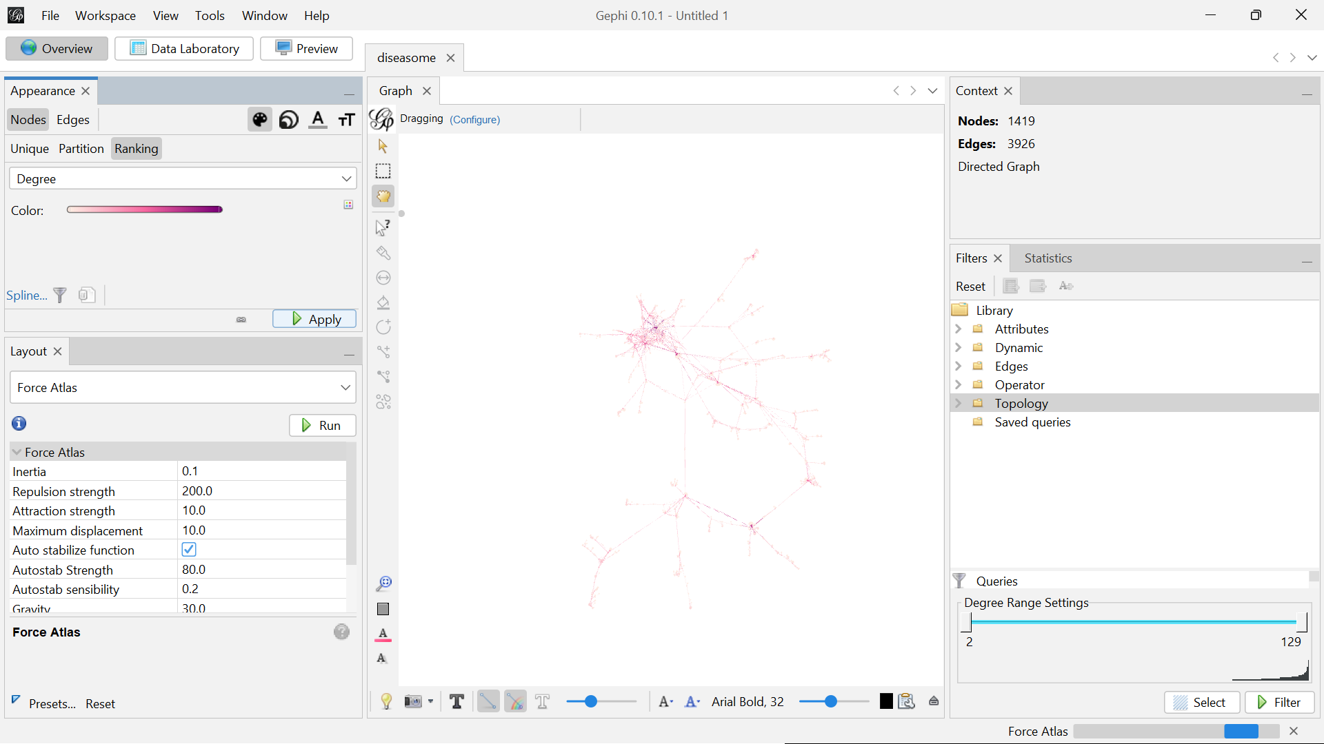

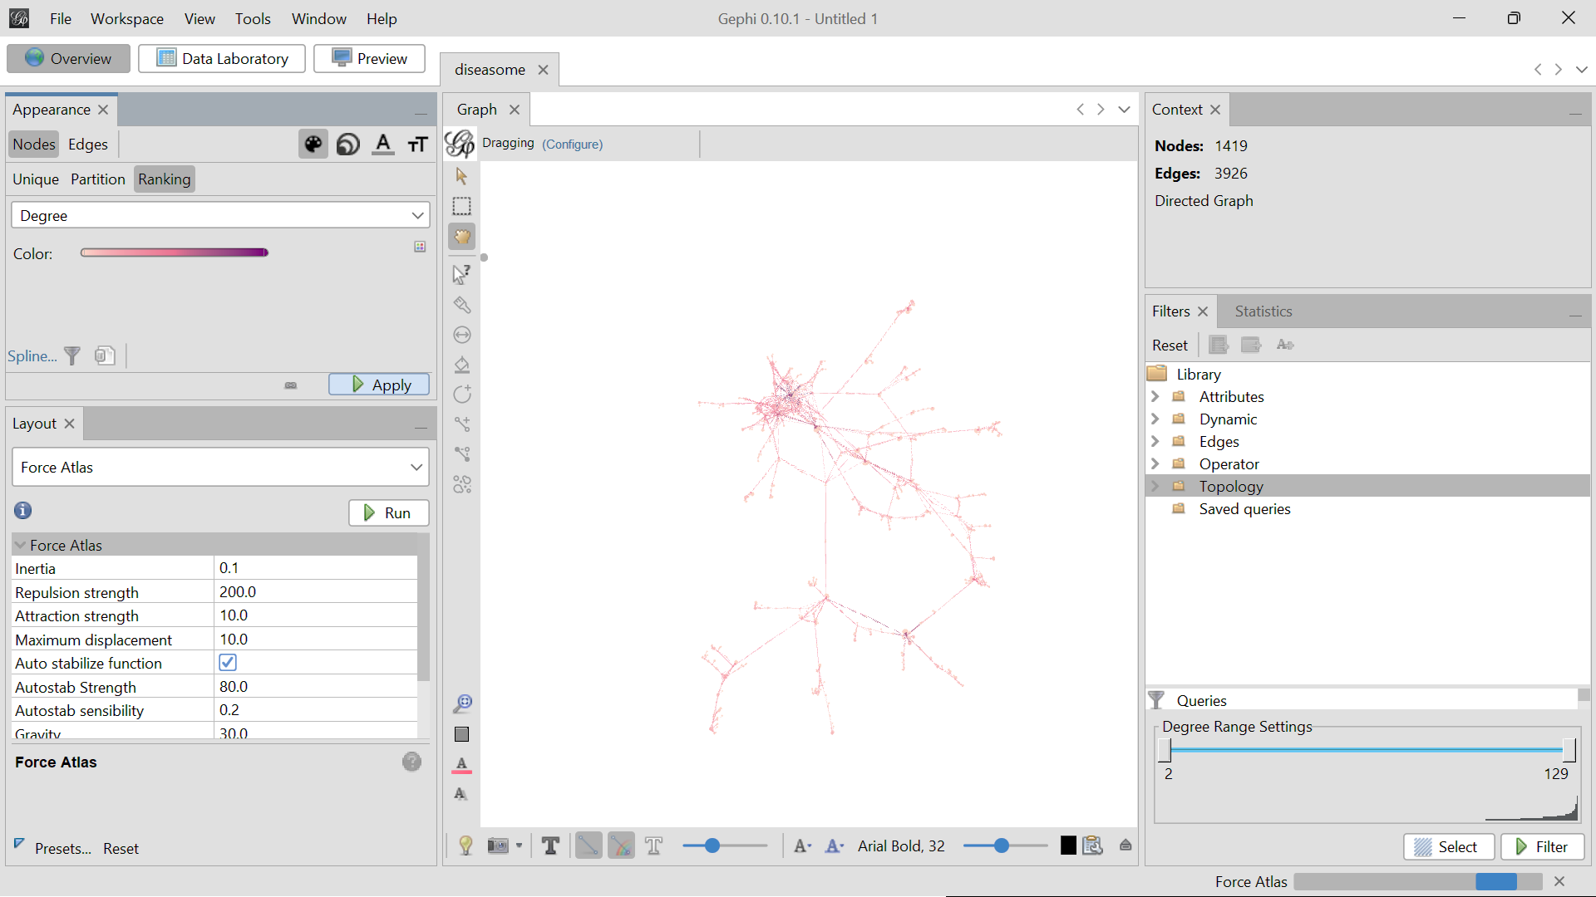

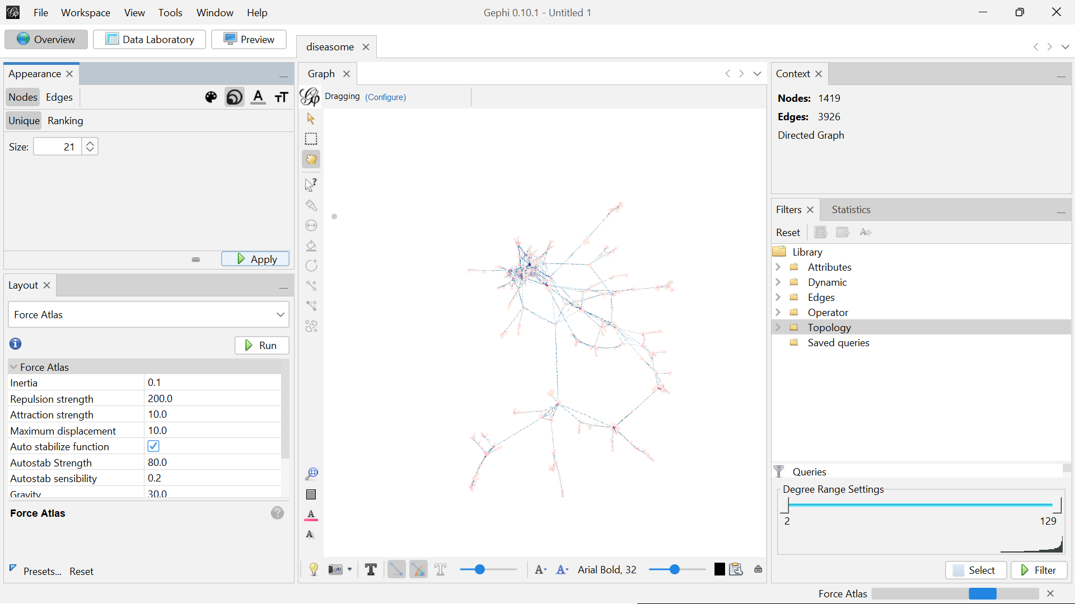

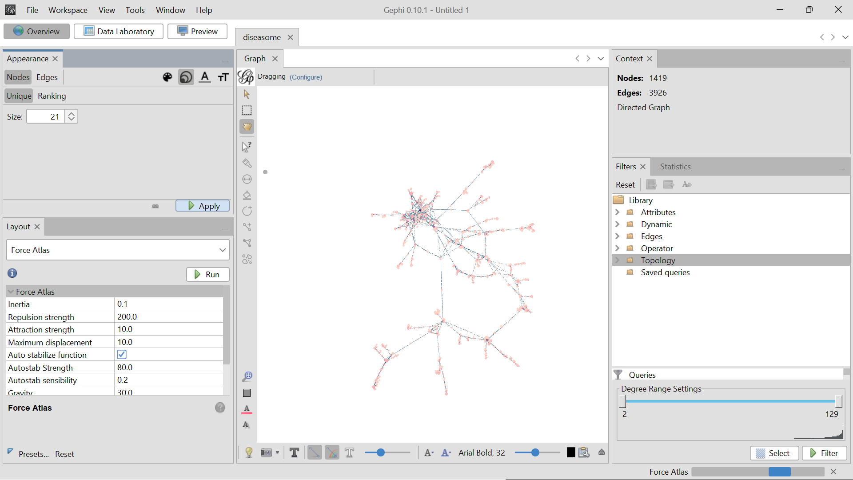

**Based on Edges:**

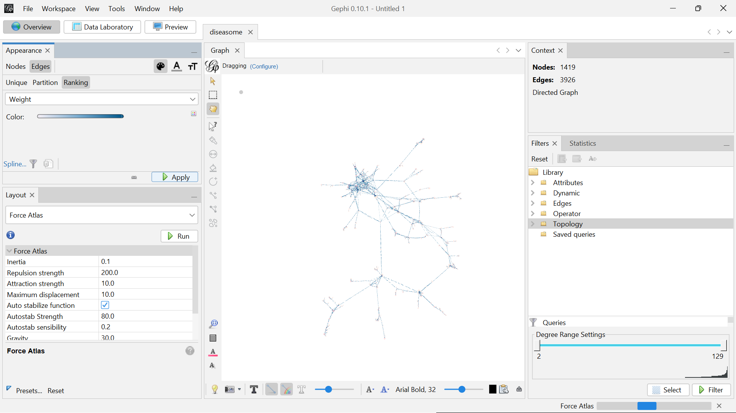

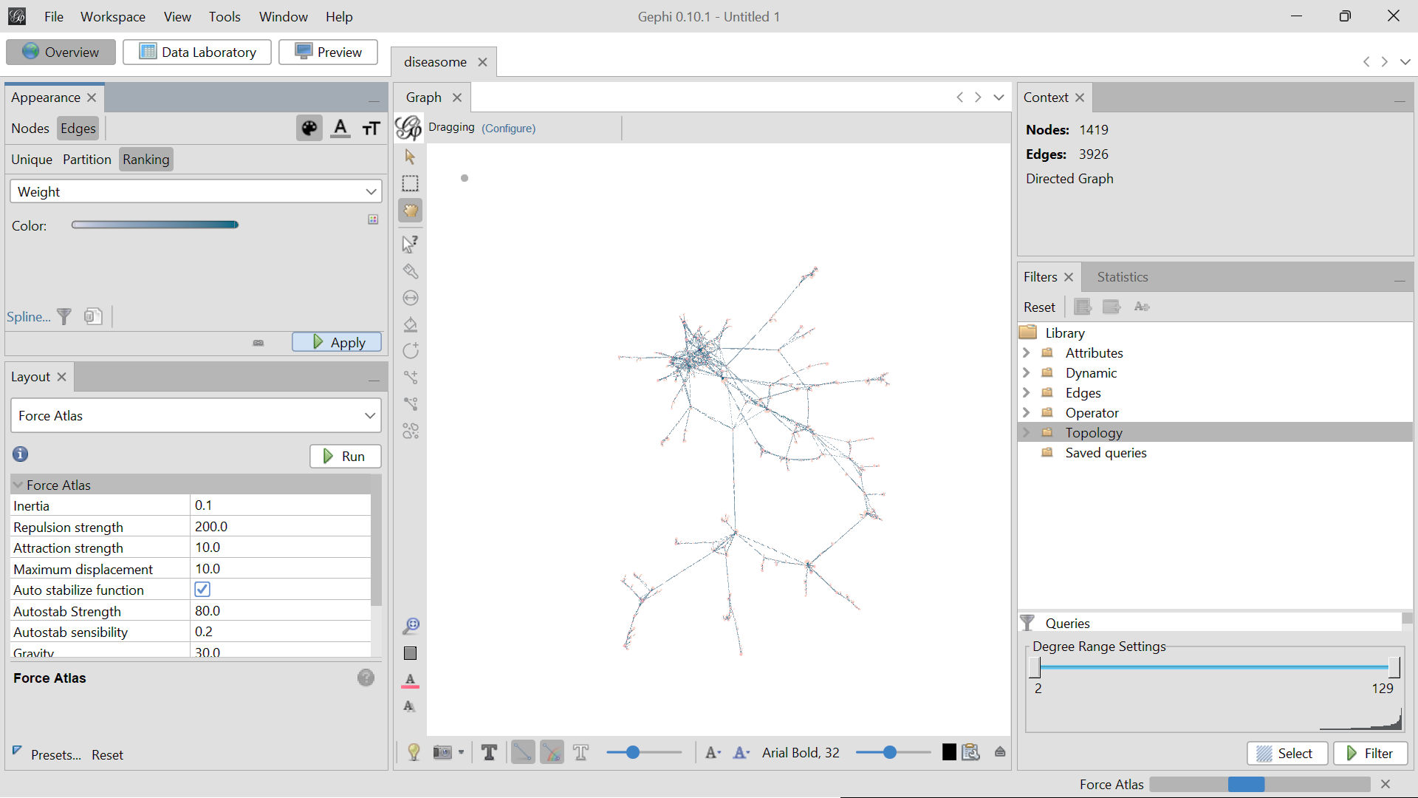

**Use cases of Topologies:**

**Degree Range**

The Degree Range option under the Topology tab in Gephi is a tool used to filter and visualize nodes based on their degree (the number of connections each node has). It allows you to select and view nodes within a specified range of degrees, helping you focus on nodes with particular levels of connectivity.

